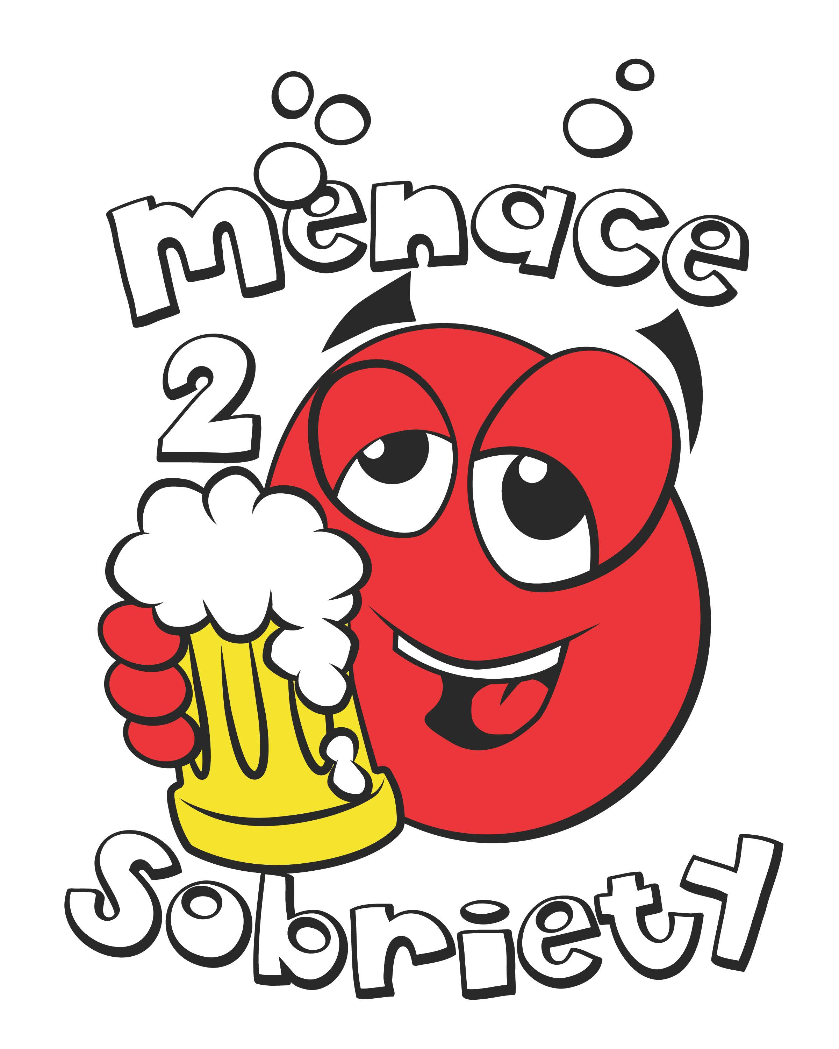
Menace 2 Sobriety Beer Olympics Tournament
ADULT PARTICIPANT WAIVER, RELEASE & INDEMNIFICATION

Player Waiver, Release of Liability and Indemnification Agreement Please read carefully and sign by initialing:
I, the undersigned, declare that I am at least 18 years old in order to participate.
For and in consideration for my participation in the Menace 2 Sobriety Beer Olympics Tournament (“Event”), I hereby, for myself and on behalf of my heirs, assigns, successors, personal representatives, administrators and next-of-kin, assume any and all risks associated with my participation in the Event, and hereby voluntarily RELEASE and WAIVE any and all rights and claims I may now, or in the future, have against Event staff, officers/hosts, officials, agents and/or volunteers, other participants, sponsoring agencies, sponsors, advertisers and owners and lessor of premises used to conduct the Event (“Releasees”), with respect to any and all injury, disability, death, or loss of damage to person or property, to the fullest extent permitted by laws, whether caused by the negligence of the Releasees or otherwise. I further agree to INDEMNIFY and HOLD HARMLESS the Releasees from any and all claims, damages, liabilities, and/or costs arising out of, connected with or in any way associated with my participation in the Event and release and waive all claims against Releasees for damages, liabilities or loss that may arise therefrom.
I understand that there is an inherent risk of injury from the activities involved the Event, and I knowingly and freely assume all such risks, both known and unknown, even if arising from the negligence of the Releasees or others, and assume full responsibility for my participation.
I acknowledge that the Releasees are not responsible for any inclement weather which may affect the Event and release and waive all claims against the Releasees for damage, liabilities or loss that may arise therefrom.
I agree and consent that Event staff reserves the right to use any pictures or videos taken during the Event for advertising and/or promotional purposes.
This document is intended to be as broad and inclusive as permitted by law, and if any portion hereof is held invalid, it is agreed that the balance shall notwithstanding, continue in full legal force and effect. This full waiver, release and indemnification embodies the entire agreement with respect to these matters and supersedes any previous or contemporaneous negotiations or agreements. I agree that no promise or inducement has been offered except as herein set forth, and that this waiver, release and indemnification has not been executed based upon statements or representations by any person or entity other than those set forth herein.
I understand that my signature is a legal and binding signature and will be considered original if received by electronic means.
I have read, understand and voluntarily sign this agreement, and further agree that no oral representations, statements, or inducements apart from the above written agreement have been made.

ALL PLAYERS MUST AGREE TO AND SIGN WAIVER TO BE ELIGIBLE TO PARTICIPATE IN THE BEER OLYMPICS EVENT.

